

Winning Space Race With Data Science

Devendra

Kumar

21/01/2023



•

Executive Summary

•

Introduction

•

Methodology

•

Results

•

Conclusion

•

Appendix

Outline



3

•

Summary of methodologies

•

Data Collection via API, Web Scraping

•

Exploratory Data Analysis (EDA) with Data Visualization

•

EDA with SQL

•

Interactive Map with Folium

•

Dashboards with Plotly Dash

•

Predictive Analysis

•

Summary of all results

•

Exploratory Data Analysis results

•

Interactive maps and dashboard

•

Predictive results

Executive Summary



Introduction

•

Project background and context

•

The aim of this project is to predict if the Falcon 9 first stage will

successfully

land.

SpaceX says

on its website that the Falcon 9

rocket launch cost 62 million dollars. Other providers cost upward

of 165 million dollars each. The price difference is explained by the fact that SpaceX can reuse the

first stage. By determining if the stage will land, we can determine the cost of a launch. This

information is interesting for another company if it wants to compete with SpaceX for a rocket

launch.

•

Problems you want to find answers

•

What are the main characteristics of a successful or failed landing ?

•

What are the effects of each relationship of the rocket variables on the success or failure of a

landing ?

•

What are the conditions which will allow SpaceX to achieve the best landing success rate ?



5



Executive Summary

•

Data collection methodology:

•

SpaceX REST API

•

Web Scrapping from Wikipedia

•

Perform data

wrangling

•

Dropping unnecessary columns

•

One Hot Encoding for classification models

•

Perform exploratory data analysis (EDA) using visualization and

SQL

•

Perform interactive visual analytics using Folium and

Plotly

Dash

•

Perform predictive analysis using classification models

•

How to build, tune, evaluate classification models

Methodology



•

Datasets are collected from Rest SpaceX API and webscrapping Wikipedia

•

The information obtained by the API are rocket, launches, payload

information.

•

The Space X

REST API URL is api.spacexdata.com/v4/

•

The information obtained by the webscrapping of Wikipedia are launches, landing,

payload

information.

•

URL is

https://en.wikipedia.org/w/index.php?title=List_of_Falcon_9_and_Falcon_Heavy_launches&oldid=1027686922

Data Collection

SpaceX

Rest API

call

API

returns

JSON file

Make

Dataframe

from JSON

Clean

Data

and export

it

Get

HTML

response

from

Wikipedia

Extract data

with

BeautifulSoup

Make

Dataframe

Export

Data



Data Collection

–

SpaceX API

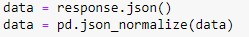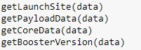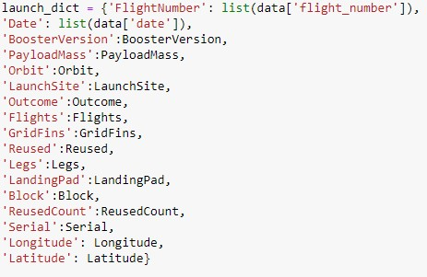

1

. Getting Response from

API

2

. Convert Response to

JSON File

3

. Transform data

4

.

Create dictionary

with data

5

. Create dataframe

6

. Filter dataframe

7

. Export to file

[Link to cod](https://github.com/Roderic19/IBM-Applied-Data-Science-Capstone/blob/main/DataCollection_API.ipynb)

[e](https://github.com/Roderic19/IBM-Applied-Data-Science-Capstone/blob/main/DataCollection_API.ipynb)



Data Collection

-

Scraping

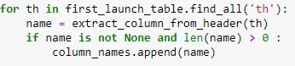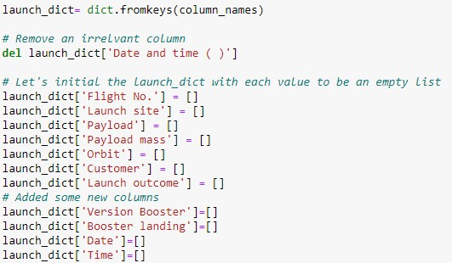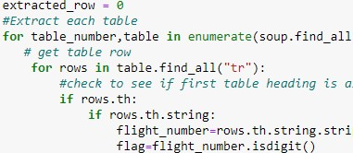

1

. Getting Response from HTML

2

. Create BeautifulSoup

Object

3

. Find all tables

4

. Get column names

5

. Create dictionary

6

. Add data to keys

**See notebook for the rest of code**

7

. Create dataframe from dictionary

8

. Export to file

[Link to cod](https://github.com/Roderic19/IBM-Applied-Data-Science-Capstone/blob/main/DataCollection_Webscraping.ipynb)

[e](https://github.com/Roderic19/IBM-Applied-Data-Science-Capstone/blob/main/DataCollection_Webscraping.ipynb)



•

In the dataset, there are several cases where the booster did not land successully.

•

True Ocean, True RTLS, True ASDS means the mission has been successful.

•

False Ocean, False RTLS, False ASDS means the mission was a failure.

•

We need to

transform

string variables into

categorical

variables where 1 means

the

mission has been successful and 0 means the mission was

a

failure.

Data Wrangling

**1**

**. Calculate launches**

**number for each site**

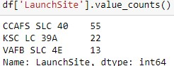

**. Calculate the number and occurence**

**2**

**of each orbit**

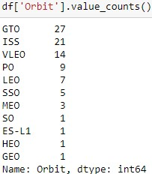

**3**

**. Calculate number and**

**occurrence of**

**mission outcome per orbit type**

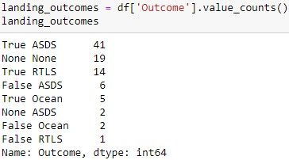

**4**

**. Create landing outcome**

**label from**

**Outcome column**

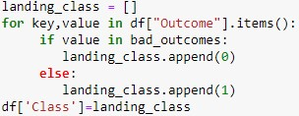

**5**

**. Export to file**



[Link to cod](https://github.com/Roderic19/IBM-Applied-Data-Science-Capstone/blob/main/DataWrangling.ipynb)

[e](https://github.com/Roderic19/IBM-Applied-Data-Science-Capstone/blob/main/DataWrangling.ipynb)



•

Scatter Graphs

•

Flight Number vs. Payload Mass

•

Flight Number vs. Launch Site

•

Payload vs. Launch Site

•

Orbit vs. Flight Number

•

Payload vs. Orbit Type

•

Orbit vs. Payload Mass

EDA with Data Visualization

•

Bar Graph

•

Success rate vs. Orbit

•

Line Graph

•

Success rate vs. Year

Scatter plots show relationship between

variables.

This relationship is called the correlation.

Bar graphs show the relationship between

numeric and categoric variables.

Line graphs show data variables and their trends.

Line graphs can help to

show global behavior

and make prediction for unseen data.

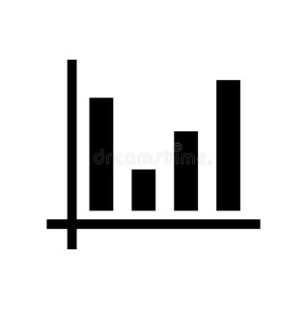

[Link to cod](https://github.com/Roderic19/IBM-Applied-Data-Science-Capstone/blob/main/EDA_DataVisualization.ipynb)

[e](https://github.com/Roderic19/IBM-Applied-Data-Science-Capstone/blob/main/EDA_DataVisualization.ipynb)



•

We performed SQL queries to gather and understand data from dataset:

•

Displaying the names of the unique lauunch sites in the space mission.

•

Display 5 records where launch sites begin with the string 'CCA'

•

Display the total payload mass carried by boosters launched by NASA (CRS).

•

Display average payload mass carried by booster version F9 v1.1.

•

List the date when the first successful landing outcome in ground pad was achieved.

•

List the names of the boosters which have success in drone ship and have payload mass greater than 4000 but less than 6000.

•

List the total number of successful and failure mission outcomes.

•

List the names of the booster_versions which have carried the maximum payload mass.

•

List the records which will display the month names, faiilure landing_ouutcomes in drone ship, booster versions, launch_site

for

the

months in year 2015.

•

Rank the count of successful landiing_outcomes between the date

04

-

06

-

2010

and

20

-

03

-

2017

in descending order.

EDA with

SQL

[Link to cod](https://github.com/Roderic19/IBM-Applied-Data-Science-Capstone/blob/main/EDA_SQL.ipynb)

[e](https://github.com/Roderic19/IBM-Applied-Data-Science-Capstone/blob/main/EDA_SQL.ipynb)



•

Folium map object is a map centered on NASA Johnson Space Center at Houson, Texas

•

Red circle at NASA Johnson Space Center's coordinate with label showing its name

(

folium.Circle, folium.map.Marker

).

•

Red circles at each launch site coordinates with label showing launch site name

(

folium.Circle, folium.map.Marker,

folium.features.DivIcon).

•

The grouping of points in a cluster to display multiple and different information for the same coordinates

(

folium.plugins.MarkerCluster

).

•

Markers to show successful and unsuccessful landings.

Green

for successful landing and

Red

for unsuccessful landing.

(

folium.map.Marker, folium.Icon

).

•

Markers to show distance between launch site to key locations (railway, highway, coastway, city) and plot a line between them

.

(

folium.map.Marker, folium.PolyLine, folium.features.DivIcon

*)*

•

These objects are created in order to understand better the problem and the data.

We can show easily

all launch sites, their

surroundings and the

number of successful and unsuccessful landings.

Build an Interactive Map with Folium

[Link to cod](https://github.com/Roderic19/IBM-Applied-Data-Science-Capstone/blob/main/LaunchSite_Location.ipynb)

[e](https://github.com/Roderic19/IBM-Applied-Data-Science-Capstone/blob/main/LaunchSite_Location.ipynb)



•

Dashboard has

dropdown,

pie chart,

rangeslider and

scatter plot components

•

Dropdown

allows a user to choose the launch site or all launch sites

(

dash_core_components.Dropdown

)

.

•

Pie chart shows the total success and the total failure for the launch site chosen with the

dropdown component

(

plotly.express.pie

)

.

•

Rangeslider allows a user to select a payload mass in a fixed range

(

dash_core_components.RangeSlider)

.

•

Scatter chart shows

the relationship between two variables, in particular Success vs

Payload Mass

(

plotly.express.scatter)

.

Build a Dashboard with

Plotly

Dash

[Link to cod](https://github.com/Roderic19/IBM-Applied-Data-Science-Capstone/blob/main/spacex_dash_app.py)

[e](https://github.com/Roderic19/IBM-Applied-Data-Science-Capstone/blob/main/spacex_dash_app.py)



•

Data preparation

•

Load dataset

•

Normalize data

•

Split data into training and test sets.

•

Model preparation

•

Selection of machine learning algorithms

•

Set parameters for each algorithm to GridSearchCV

•

Training GridSearchModel models with training dataset

•

Model evaluation

•

Get best hyperparameters for each type of model

•

Compute accuracy for each model with test dataset

•

Plot Confusion Matrix

•

Model comparison

•

Comparison of models according to their accuracy

•

The model with the best accuracy will be chosen (see Notebook for result)

Predictive Analysis (Classification)

[Link to cod](https://github.com/Roderic19/IBM-Applied-Data-Science-Capstone/blob/main/Machine%20Learning%20Prediction.ipynb)

[e](https://github.com/Roderic19/IBM-Applied-Data-Science-Capstone/blob/main/Machine%20Learning%20Prediction.ipynb)



•

Exploratory data analysis results

•

Interactive analytics demo in screenshots

•

Predictive analysis results

Results





We observe that, for each site, the success rate is increasing.

Flight Number vs. Launch

Site

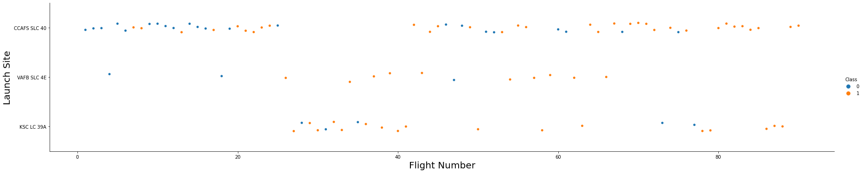

Depending on the launch site, a heavier payload may be a consideration for a successful landing. On

the other hand, a too heavy payload can make a landing fail.

Payload vs. Launch Site

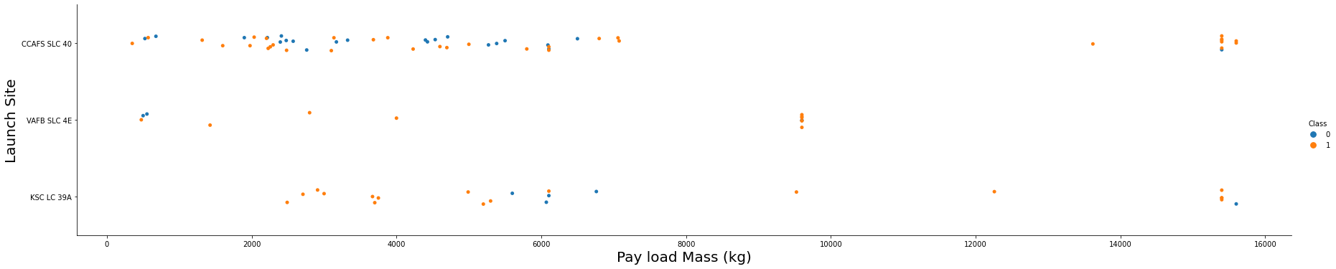

With this plot, we can see success rate for different orbit types. We note that ES

-

L1, GEO,

HEO, SSO have the

best success rate.

Success Rate vs. Orbit Type

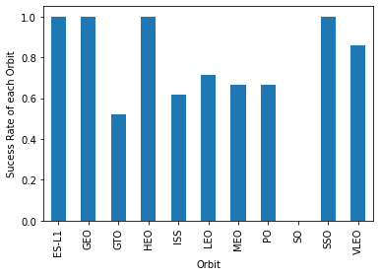

We notice that the success rate increases with the number of flights for the LEO orbit.

For some orbits like

GTO, there is no relation between the success rate and the number of

flights. But we can suppose that the

high success rate of some orbits like SSO or HEO is due to the knowledge learned during former launches

for other orbits.

Flight Number vs. Orbit Type

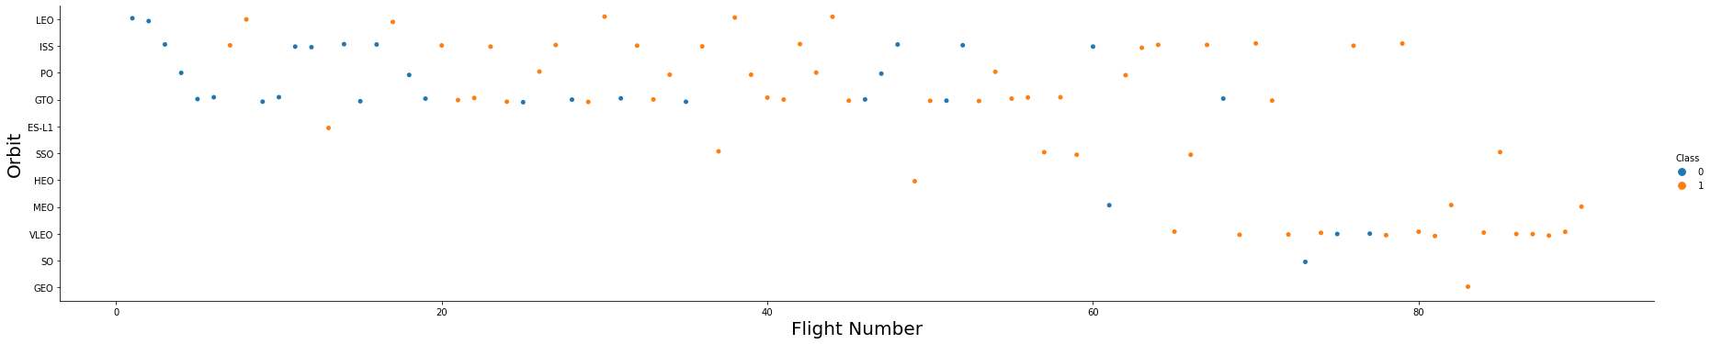

The weight of the payloads can have a great influence on the success rate of the launches in certain

orbits. For example, heavier payloads improve the success rate for the LEO orbit.

Another finding is that

decreasing the payload weight for a GTO orbit improves the success of a launch.

Payload vs. Orbit

Type

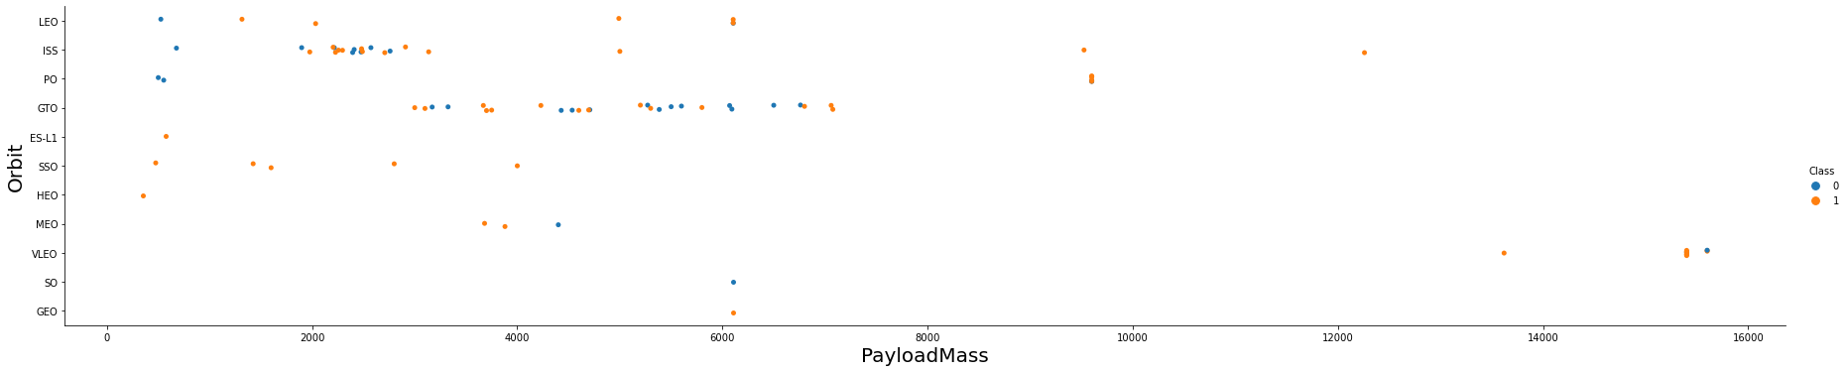

Since 2013, we can see an increase in the Space X Rocket success rate.

Launch Success Yearly Trend

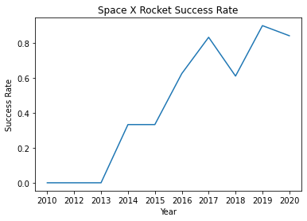

All Launch Site Names



SQL Query

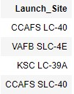

Results

Explanation

The use of DISTINCT in the query allows to remove

duplicate LAUNCH_SITE.



Launch Site Names Begin with 'CCA'

Results

SQL Query

Explanation

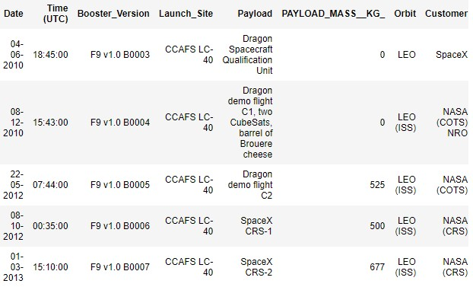

The WHERE clause followed by LIKE clause filters

launch

sites

that contain the substring CCA.

LIMIT 5 shows 5 records from filtering.



Total Payload Mass

SQL Query

Results

Explanation

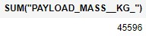

This query returns the sum of all payload masses

where the customer is NASA (CRS).



Average Payload Mass by F9 v1.1

SQL Query

Results

Explanation

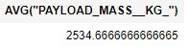

This query returns the average of all payload masses

where the booster version contains the substring F9

v1.1.



First Successful Ground Landing Date

SQL Query

Results

Explanation

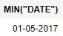

With this query, we select the oldest successful

landing.

The WHERE clause filters dataset in order to keep only

records where landing was successful. With the MIN

function, we select the record with the oldest date.



Successful Drone Ship Landing with Payload between 4000 and 6000

SQL Query

Results

Explanation

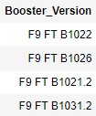

This query returns the booster version where landing

was successful and payload mass is between 4000

and 6000

kg. The WHERE and AND clauses filter the

dataset.



Total Number of Successful and Failure

Mission Outcomes

SQL Query

Results

Explanation

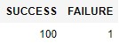

With the first SELECT, we show the subqueries that

return results. The first subquery counts the successful

mission. The second subquery counts the unsuccessful

mission.

The WHERE clause followed by LIKE clause

filters mission outcome

. The COUNT function counts

records filtered.



Boosters Carried Maximum

Payload

SQL Query

Results

Explanation

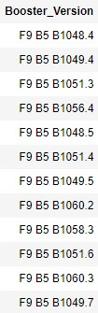

We used a subquery to filter data by returning only

the heaviest payload mass with MAX function. The

main

query uses subquery results and returns unique

booster version

(

SELECT DISTINCT) with the heaviest

payload mass.



2015

Launch Records

SQL Query

Results

Explanation

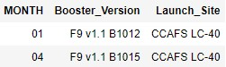

This query returns month, booster version, launch site

where landing was unsuccessful and landing date took

place in

2015

. Substr function process date in order

to

take month or year. Substr(DATE, 4, 2) shows

month. Substr(DATE,7, 4) shows year.



Rank Landing Outcomes Between 2010

-

06

-

04

and

2017

-

03

-

20

SQL Query

Results

Explanation

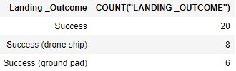

This query returns landing outcomes and their

count

where mission was successful and date is

between 04/06/2010 and 20/03/2017. The GROUP

BY clause

groups results by landing outcome and

ORDER BY COUNT

DESC shows results in decreasing

order.





We see that Space X launch sites are located on the coast of the United States

Folium map

–

Ground stations

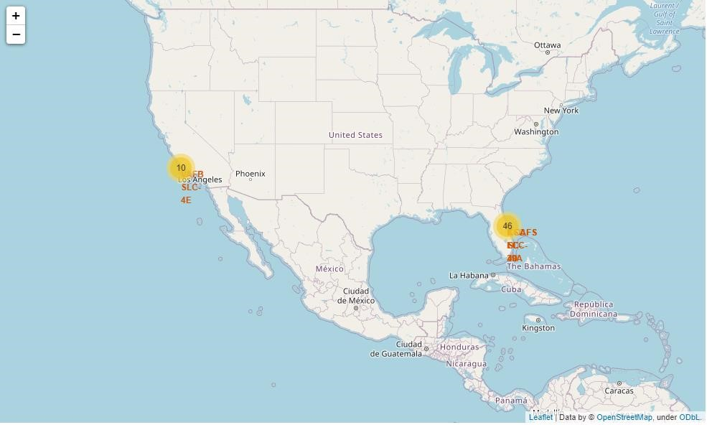

36

Green

marker represents successful launches.

Red

marker represents unsuccessful

launches. We

note that KSC LC

-

39

A has a higher launch success rate.

Folium map

–

Color Labeled Markers

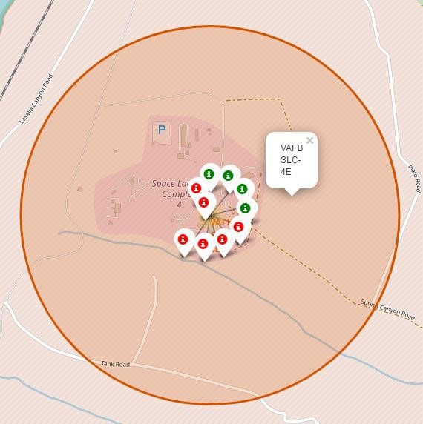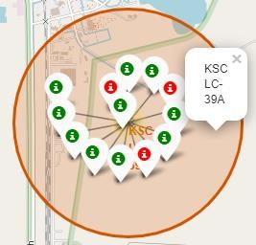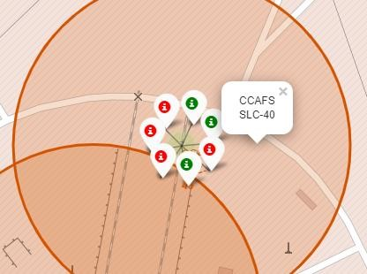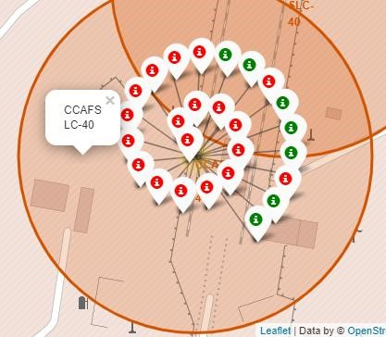

Is CCAFS SLC

-

40

in close proximity to railways ? Yes

Is CCAFS SLC

-

40

in close proximity to highways ? Yes

Is CCAFS SLC

-

40

in close proximity to coastline ? Yes

Do

CCAFS SLC

-

40

keeps certain distance away from cities ? No

Folium Map

–

Distances between CCAFS SLC

-

40

and its proximities

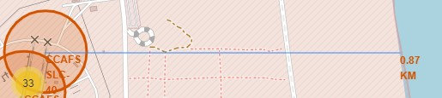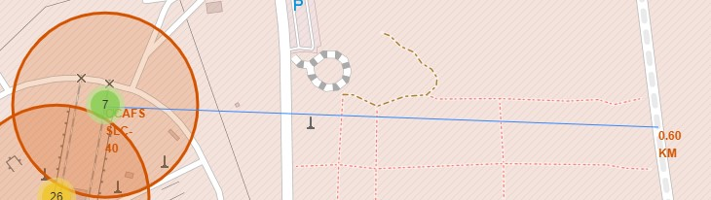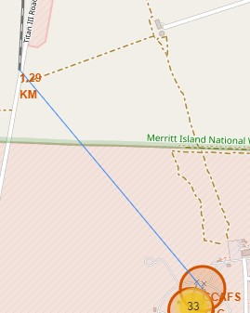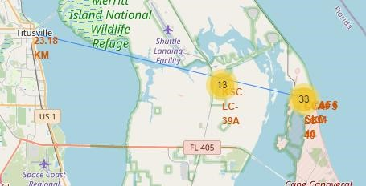





We see that KSC LC

-

39

A has the best success rate of launches.

Dashboard

–

Total success by Site

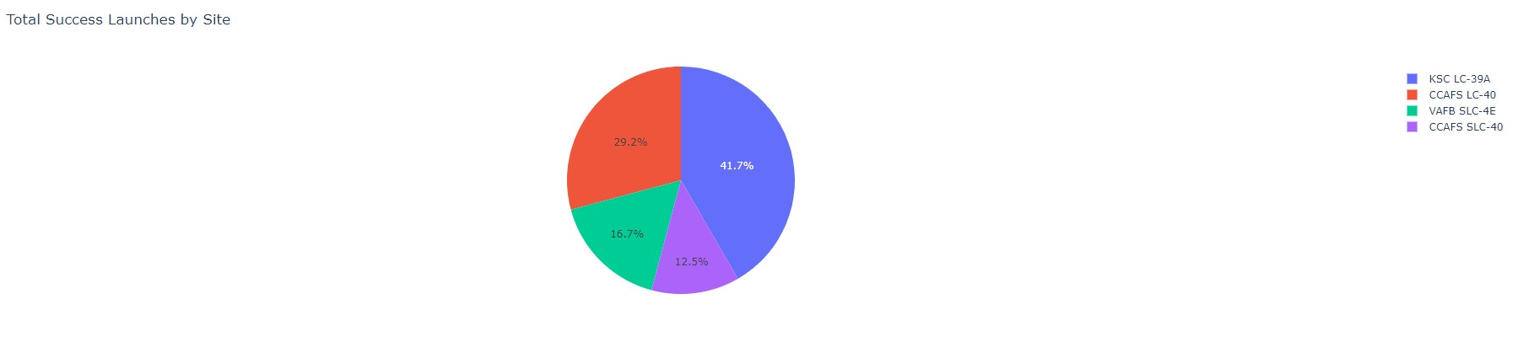

40

We see that KSC LC

-

39

A has achieved a

76.9

%

success rate

while getting a 23.1%

failure rate.

Dashboard

–

Total success launches for Site KSC LC

-

39

A

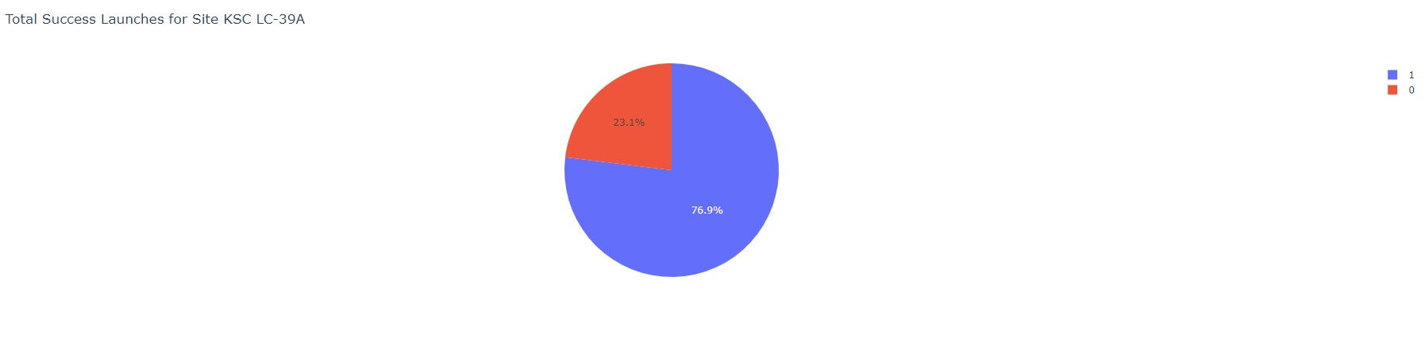

Low weighted payloads have a better success rate than the heavy weighted payloads.

Dashboard

–

Payload mass vs Outcome for all sites with different payload mass selected

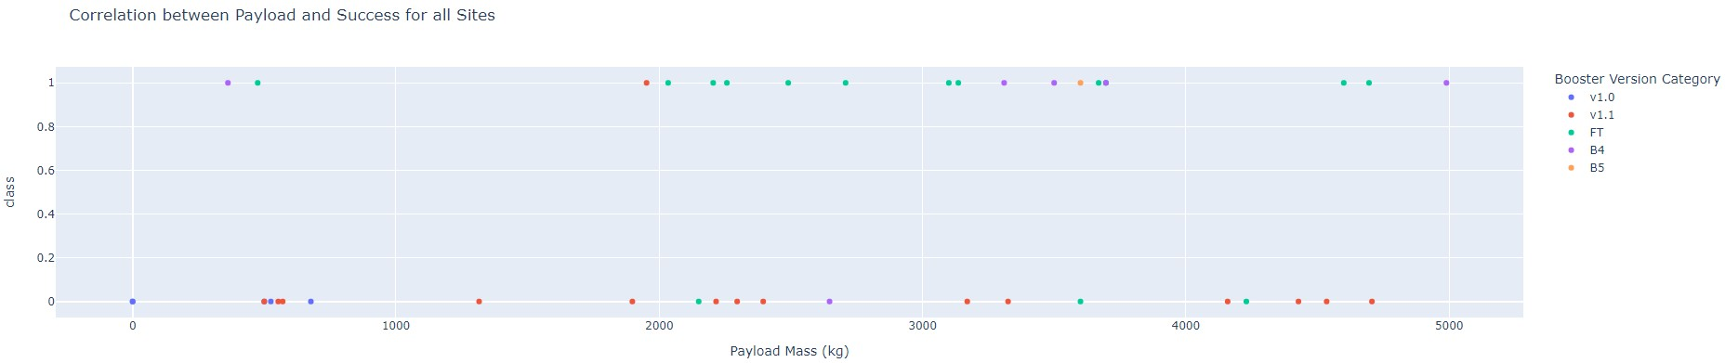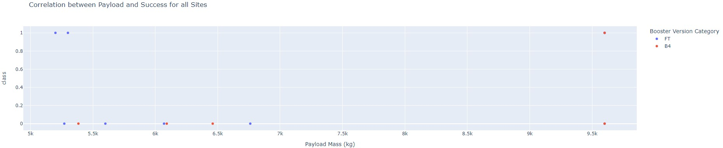

**Low weighted payload (0**

**–**

**5000**

**kg**

**)**

**Heavy weighted payload (5000**

**–**

**10000**

**kg**

**)**





For accuracy test, all methods performed similar.

We could get more test data to decide between

them.

But i

f we really need to choose one right now, we would take the decision tree.

Classification Accuracy

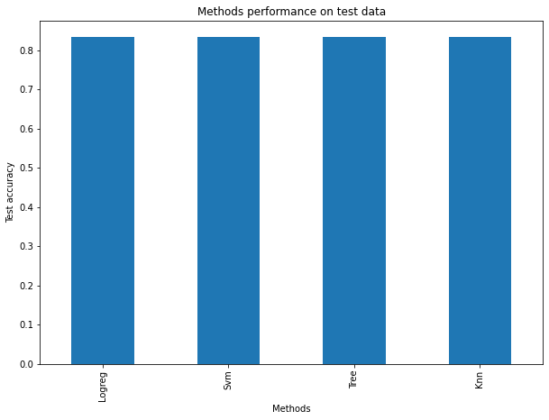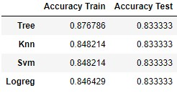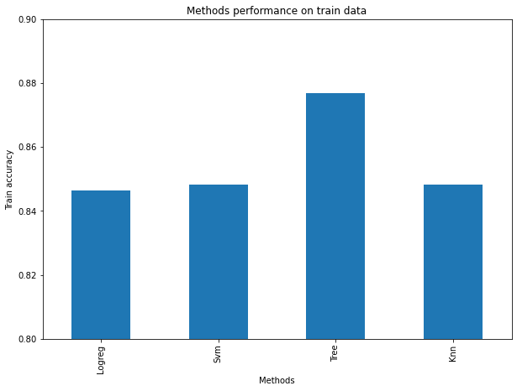

Decision tree best parameters



As the test accuracy are all equal,

the confusion matrices are also

identical.

The main problem of

these models are false positives.

Confusion Matrix

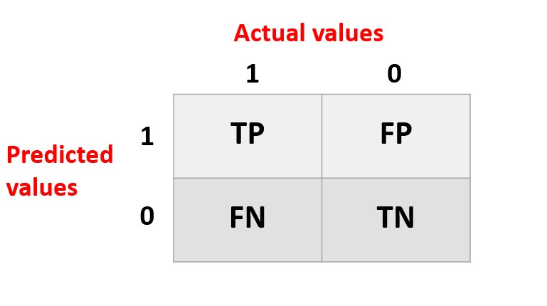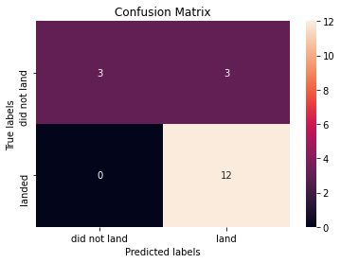

**Logistic regression**



**kNN**

**Decision Tree**

**SVM**



•

The success of a mission can be explained by several factors such as the launch site,

the orbit and

especially the number of previous launches. Indeed, we can assume that there has been a gain in

knowledge between launches that allowed to go from a launch failure to a success.

•

The orbits with the best success rates are

GEO, HEO, SSO, ES

-

L1.

•

Depending on the orbits, the payload mass can be a criterion to take into account for the success of a

mission. Some orbits require a light or heavy payload mass. But generally

low weighted

payloads

perform better than the

heavy weighted payloads.

•

With the current data, we cannot explain why some launch sites are better than others (KSC LC

-

39

A is

the best launch site). To get an answer to this problem, we could obtain atmospheric or other relevant

data.

•

For this dataset, we choose the Decision Tree Algorithm

as the best model even if the test

accuracy

between all the models used is identical. We choose Decision Tree Algorithm

because it has a better

train accuracy.

Conclusions

